Q3 2026 Business Review
Northwind Technologies · Board quarterly report
Business Operations · Finance
October 15, 2026

1 Key figures
The group booked USD 68.0 million in revenue in Q3, up ▲ 18.4% year on year — the sixth quarter in a row of double-digit growth. Gross margin reached 32.7%, a record since the IPO. Operating cash flow exceeded net profit for the first time; days sales outstanding remain above target and are a priority for Q4.
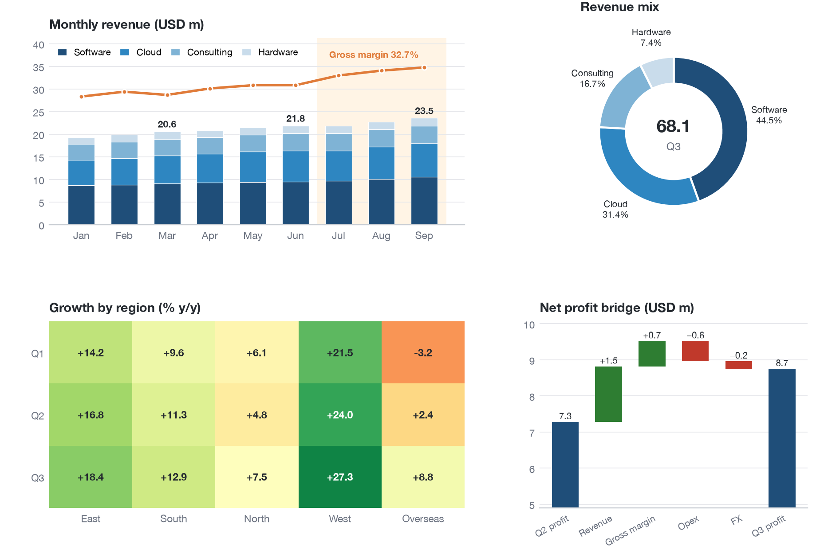
Figure 1. Q3 dashboard: (a) monthly revenue by product line and gross margin; (b) revenue mix; (c) growth by region; (d) net profit bridge
Table 1. Key figures against budget, Q3 2026
Area | Measure | Q3 2026 |  |  | y/y | Status
Area | Measure | Actual | Budget | vs budget | y/y | Status
Scale | Revenue (USD m) | 68.0 | 64.4 | 105.7% | +18.4% | ● Ahead
Scale | New contracts (USD m) | 85.7 | 77.0 | 111.3% | +26.1% | ● Ahead
Profit | Gross margin | 32.7% | 31.5% | +1.2 pt | +1.9 pt | ● Ahead
Profit | Net profit (USD m) | 8.7 | 8.4 | 103.3% | +21.6% | ● On track
Cash | Operating cash flow (USD m) | 9.9 | 7.7 | 129.1% | +48.0% | ● Ahead
Cash | Days sales outstanding | 96 | 85 | −11 days | +7 days | ▲ Watch
Important
Cloud now makes up 31.4% of revenue (Figure 1b) and has become our second growth engine; the West has led regional growth for three quarters running.

2 Regions
Table 2. Revenue by region and product line (USD m)
Region | Market | Software |  | Cloud |  | Total
Region | Market | Q3 | y/y | Q3 | y/y | Total
East | New York | 5.9 | +12% | 4.3 | +41% | 12.0
East | Boston | 5.3 | +19% | 3.4 | +36% | 9.9
East | Philadelphia | 4.6 | +15% | 2.8 | +28% | 8.4
South | Atlanta | 5.0 | +9% | 3.1 | +24% | 9.2
South | Miami | 2.0 | +6% | 1.0 | +18% | 3.4
North | Chicago, Detroit | 4.1 | −2% | 2.5 | +15% | 7.7
West | Seattle, Denver | 2.9 | +22% | 2.8 | +47% | 7.0
Overseas | SE Asia, Middle East | 0.4 | — | 1.5 | +120% | 2.5
Group total |  | 30.2 | +22.5% | 21.4 | +31.8% | 68.0

2.1 Quality of earnings
A DuPont breakdown of return on equity shows all three drivers improving:
$ROE=\underset{\text{margin} 12.8\%}{\underset{⏟}{\frac{\text{Net profit}}{\text{Revenue}}}}×\underset{\text{turnover} 0.64}{\underset{⏟}{\frac{\text{Revenue}}{\text{Total assets}}}}×\underset{\text{leverage} 1.71}{\underset{⏟}{\frac{\text{Total assets}}{\text{Equity}}}}≈14.0\%$ (1)
Customer lifetime value follows Eq. (2); for cloud, $LTV/CAC=4.3$, well above the industry rule of thumb of 3.0:
$LTV=\sum_{t=1}^{T}{\frac{m⋅{ARPU}_{t}⋅r^{ t−1}}{(1+d)^{t}}}, r=1−\text{churn}, d=8\%$ (2)
Management view
Of the margin gain, 0.9 pt comes from the product mix (more high-margin cloud) and 0.3 pt from delivery automation; see Key figures and Table 2.

3 Risks and Q4 plan
Table 3. Main risks and responses
Risk | Likelihood | Impact | Response | Owner
Late payment by key accounts | High | High | Staged milestones in contracts, weekly collection | Finance
Software decline in the North | Med | Med | Channel changes, subscription bundle | North region
Currency swings overseas | Med | Low | Forwards covering 60% of exposure | Treasury
- ☒ Grow the cloud delivery team by 30 (22 hired)
- ☒ Launch deployment automation platform 2.0
- ☐ Bring days sales outstanding below 85
- ☐ Open a local service centre in the Middle East
“Quality of growth matters more than speed.” — Chair, Q3 operating review

Days sales outstanding = closing receivables ÷ quarterly revenue × 91.

