Attention-Weighted Physics-Informed Neural Networks for the Unsteady Navier–Stokes Equations
Ming Wang¹, Hua Li^{1,2}, Siyuan Chen²
September 2026
Abstract
Physics-informed neural networks (PINNs) often fail to converge on unsteady flows at high Reynolds numbers because the gradients of their loss terms are badly out of balance. We propose Attn-PINN, which uses an attention mechanism to weight the residuals adaptively, and prove an upper bound on its approximation error. For flow past a cylinder ($Re=3 900$), Attn-PINN reaches a relative $L^{2}$ error of $1.7×{10}^{−3}$ — an order of magnitude below the baseline — while training 41% faster.

1 Introduction
PINNs embed the residual of a partial differential equation in the loss of a neural network^{[1]}. They need no mesh and solve forward and inverse problems alike, and have become a core method of scientific machine learning^{[2]}. For the strongly nonlinear Navier–Stokes equations, however, the gradients of the individual loss terms can differ by more than ${10}^{3}$, trapping training in a “gradient pathology”^{[3]}. Neural operators^{[4]} ease the problem but need large amounts of labelled data. Borrowing the attention mechanism of the Transformer^{[5]}, we let the network learn the weight of every collocation point during training.

2 Problem statement
Consider incompressible viscous flow in a domain $Ω⊂R^{2}$. The velocity $u=(u,v)^{⊤}$ and pressure $p$ satisfy
$\left\{\begin{aligned}\frac{∂u}{∂t}+(u⋅∇)u&=−\frac{1}{ρ}∇p+ν ∇^{2}u+f,&&(x,t)∈Ω×(0,T], \\ ∇⋅u&=0,&&(x,t)∈Ω×(0,T], \\ u(x,0)&=u_{0}(x),&&x∈Ω,\end{aligned}\right.$ (1)
where $ν$ is the kinematic viscosity. With networks ${\hat{u}}_{θ}$ and ${\hat{p}}_{θ}$ approximating the solution, the momentum residual is $r_{θ}=∂_{t}{\hat{u}}_{θ}+({\hat{u}}_{θ}⋅∇){\hat{u}}_{θ}+ρ^{−1}∇{\hat{p}}_{θ}−ν∇^{2}{\hat{u}}_{θ}−f$.

3 Method

3.1 Attention-weighted residuals
For $N_{r}$ collocation points $\{x_{i}\}$, the weights come from scaled dot-product attention over residual features:
$λ=softmax​\left(\frac{QK^{⊤}}{\sqrt{d_{k}}}\right)V, Q=\left(\begin{matrix}q_{11} & q_{12} & ⋯ & q_{1d} \\ q_{21} & q_{22} & ⋯ & q_{2d} \\ ⋮ & ⋮ & ⋱ & ⋮ \\ q_{N_{r}1} & q_{N_{r}2} & ⋯ & q_{N_{r}d}\end{matrix}\right)$ (2)
The total loss adds the weighted residual, the initial and boundary conditions and the divergence constraint:
L(θ)=1Nri=1Nrλi∥rθ(xi,ti)∥22⏟PDE residual+βNbj=1Nb∥uθ(xj,tj)−gj∥22⏟boundary+γΩ​(∇⋅uθ)2 dx (3)
The learning rate follows a piecewise cosine schedule:
$η(k)=\left\{\begin{matrix}η_{0}\frac{k}{k_{w}}, & 0≤k<k_{w}, \\ η_{min}+\frac{η_{0}−η_{min}}{2}\left[1+cos​\left(π\frac{k−k_{w}}{K−k_{w}}\right)\right], & k_{w}≤k≤K.\end{matrix}\right.$ (4)
Theorem 1 (error bound)
Let the exact solution satisfy $u∈H^{2}(Ω)$ and let the network have width $m$. If the training loss satisfies $L(θ^{*})≤ε$, there is a constant $C$ independent of $m$ such that
$∥u−{\hat{u}}_{θ^{*}}∥_{L^{2}(Ω)} ≤ C\left(\sqrt{ε}+\frac{lnm}{\sqrt{m}}\right)exp​\left(\int_{0}^{T}{{\left\|∇u(⋅,s)\right\|}_{L^{∞}}} ds\right).$ (5)
Proof sketch. An energy estimate for the error $e=u−\hat{u}$ and Grönwall’s inequality give
$$\begin{aligned}\frac{1}{2}\frac{d}{dt}{\left\|e\right\|}^{2}+ν{\left\|∇e\right\|}^{2}&≤{\left\|∇u\right\|}_{L^{∞}}{\left\|e\right\|}^{2}+\left\|r\right\| \left\|e\right\| \\ &≤\left({\left\|∇u\right\|}_{L^{∞}}+1/2\right){\left\|e\right\|}^{2}+1/2{\left\|r\right\|}^{2}.\end{aligned}$$
Integrating and substituting Eq. (3) yields Eq. (5). $◼$

4 Experiments
We test on flow past a cylinder ($Re=UD/ν=3 900$) with a network of 8 layers of 128 neurons.
Table 1. Error and training cost of each method
Method | Relative $L^{2}$ error ($×{10}^{−3}$) |  |  | Training cost
Method | $u$ | $v$ | $p$ | Time (h) | Memory (GB)
PINN^{[1]} | 18.6 | 24.1 | 41.7 | 9.8 | 6.2
GradNorm-PINN^{[3]} | 6.4 | 8.9 | 15.2 | 11.3 | 6.9
FNO^{[4]} | 3.1 | 4.0 | 7.7 | 7.6 | 14.5
Attn-PINN (ours) | 1.7 | 2.2 | 4.9 | 5.8 | 7.4
  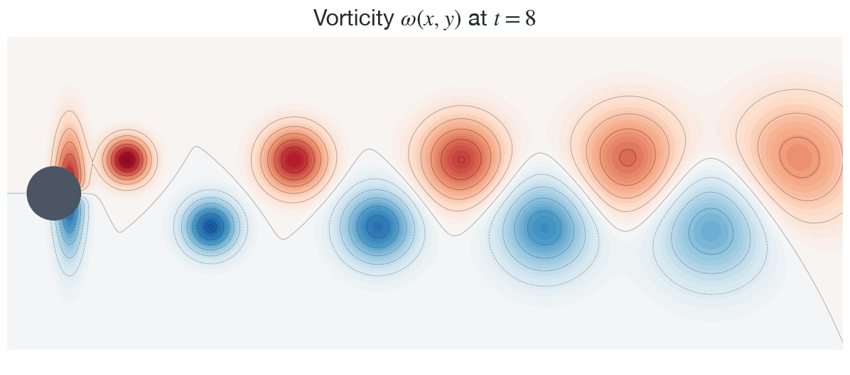
  (a) Vorticity predicted by Attn-PINN
  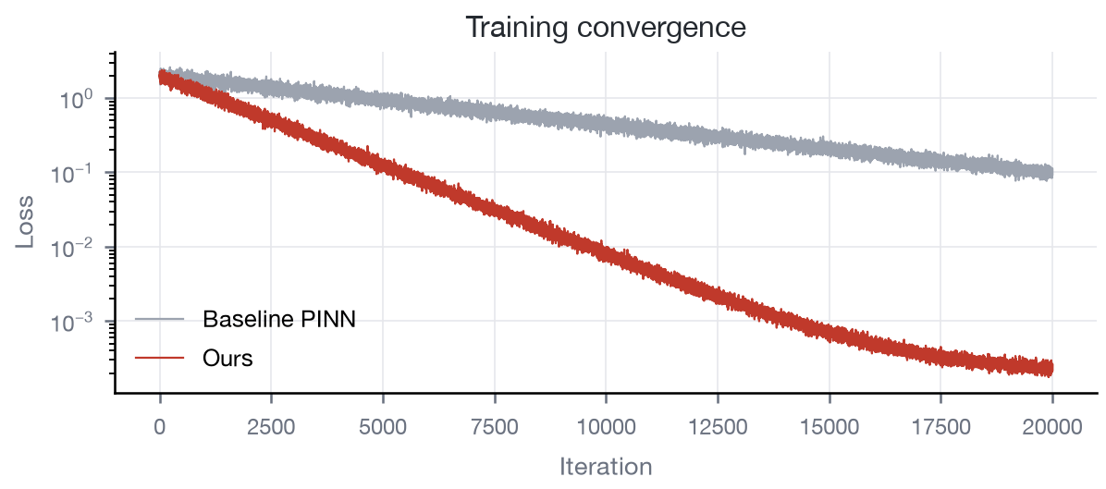
  (b) Loss during training
Figure 1. Flow past a cylinder: Attn-PINN reproduces the Kármán vortex street
As Table 1 shows, Attn-PINN has the lowest error on all three fields and trains 41% faster than the baseline PINN (Figure 1).

5 Conclusion
Attn-PINN balances the residual weights with an attention mechanism, comes with an error bound (Eq. (5)), and clearly outperforms existing methods on a high-Reynolds-number benchmark.

References
[1] RAISSI M, PERDIKARIS P, KARNIADAKIS G E. Physics-informed neural networks: A deep learning framework for solving forward and inverse problems involving nonlinear partial differential equations[J/OL]. Journal of Computational Physics, 2019, 378: 686-707. DOI:10.1016/j.jcp.2018.10.045.
[2] KARNIADAKIS G E, KEVREKIDIS I G, LU L, et al. Physics-informed machine learning[J/OL]. Nature Reviews Physics, 2021, 3(6): 422-440. DOI:10.1038/s42254-021-00314-5.
[3] WANG S, TENG Y, PERDIKARIS P. Understanding and mitigating gradient flow pathologies in physics-informed neural networks[J/OL]. SIAM Journal on Scientific Computing, 2021, 43(5): A3055-A3081. DOI:10.1137/20M1318043.
[4] LI Z, KOVACHKI N, AZIZZADENESHELI K, et al. Fourier neural operator for parametric partial differential equations[C]//International conference on learning representations. 2021.
[5] VASWANI A, SHAZEER N, PARMAR N, et al. Attention is all you need[C]//Advances in neural information processing systems. 2017: 5998-6008.

Activation $tanh$, Adam optimiser, $η_{0}={10}^{−3}$, $k_{w}=2 000$, $K=20 000$.

